[PSoC 4 Pioneer Kit Community Project#045 – Stepper Motor Example](http://www.element14.com/community/message/81998#81998/l/psoc-4-pioneer-kit-community-project045-stepper-motor-example)

In today’s example we will be showcasing a very simple stepper motor example project. In this example we show you how to spin a stepper motor using the PSoC 4 Pioneer kit and the [Arduino Motor Shield](http://www.newark.com/arduino/a000079/add-on-card-motor-shield-r3-l298p/dp/78T1603?in_merch=Popular%20Products&in_merch=Popular%20Products&MER=PPSO_N_C_EverywhereElse_None&COM=e14_CypressPSoC4PioneerKit).

[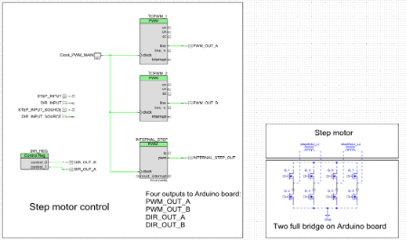](http://www.element14.com/community/servlet/JiveServlet/showImage/2-81998-160427/001+-+Schematic+Design.png)

 Forum Post Attachments:

 At the bottom of this post we are including the following items:

* Example Project Zip File
* Zip File of Images
  + Project Schematic
  + Component Configurations

 Components Used:

 The user can download the example project at the bottom of this post. The project uses the following list of Creator Components:

* PWM
* Control Register
* CyClock
* CyPin

 The components are configured by right clicking on the component in your Top Design schematic view and selecting **Configure**. Please enable the following selections in the Configuration windows for the listed components above.

 Firmware Description:

 The main.c firmware is included in the example project. Please review the commented sections for more details.

In this example we are giving users an example on how to control a Stepper Motor. In this example we have included a number of motor control source files that will provide you simple APIs to control the motor. These files are:

* genSine.c/h
* inputScan.c/h
* Move.c/h
* PhaseControl.c/h
* systemInit.c/h

 The firmware is designed to drive the stepper motor is various directions and different speeds and different lengths of time. There are a number of if/else statements that progress through the demonstration. Please take a few moments to review the included source files to get a feel for the firmware controls for the motor.

 Hardware Connections:

 Connect the Arduino Motor Shield to the PSoC 4 Pioneer Board. Then connect wires from the stepper motor to the Arduino Motor Shield and power the motor.

[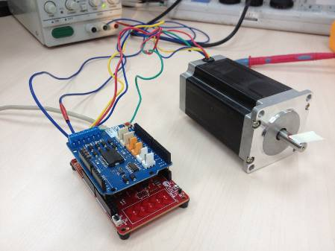](http://www.element14.com/community/servlet/JiveServlet/showImage/2-81998-160428/002+-+Stepper+Motor+Example+a.jpg)

 Test Your Project:

 Program your project and power up the Motor Shield using an external power supply.

 I hope this example can help you in your design.

<http://www.element14.com/community/message/81998>